VOCABULARY
SPORT
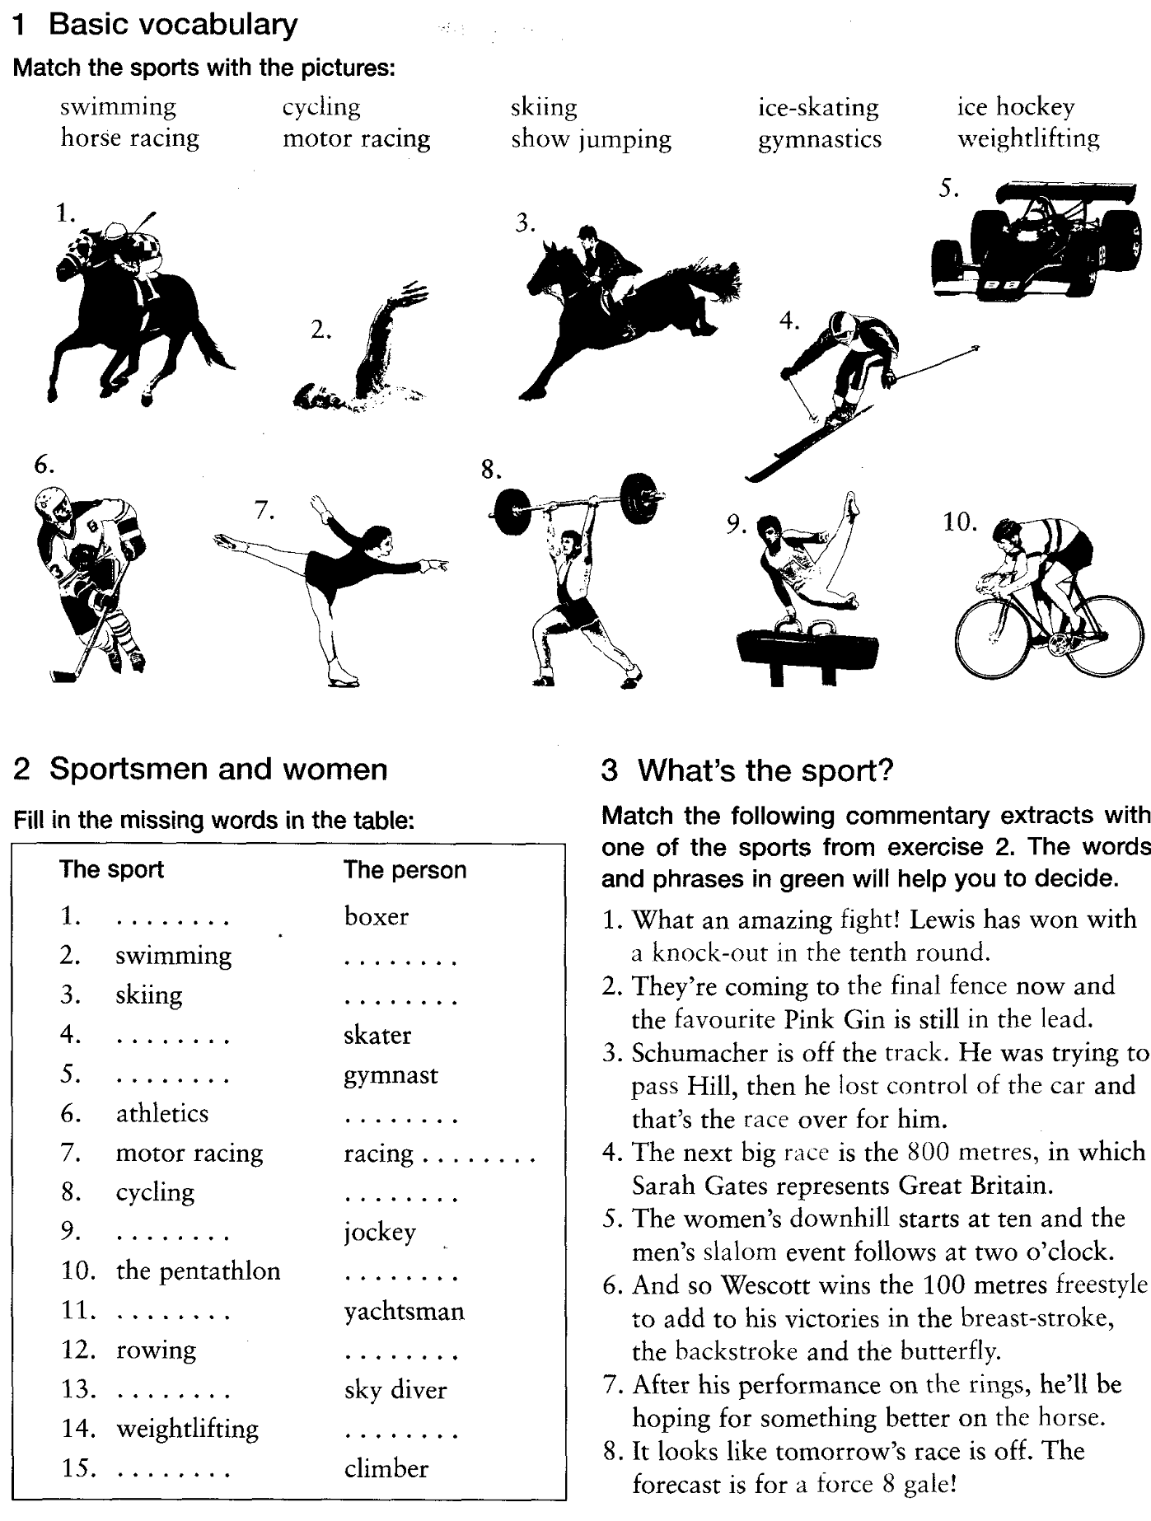

ANSWER KEYS

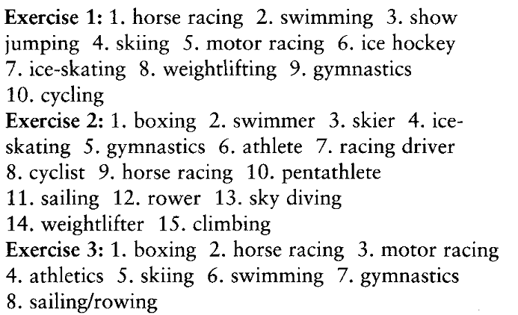

Source:
Chris Gough (2001).English Vocabulary Organiser. Language Teaching Publications

